Marmara University

CSE2260: Project 1 Report

150120031 Şükrü Can Mayda

150120073 Akın Ateş

150121545 Nurbetül Çakır

**Running the Code**

The program is written in Java coding language and can be executed on Eclipse Photon IDE by opening the .java and .class files and clicking the “Run” button.

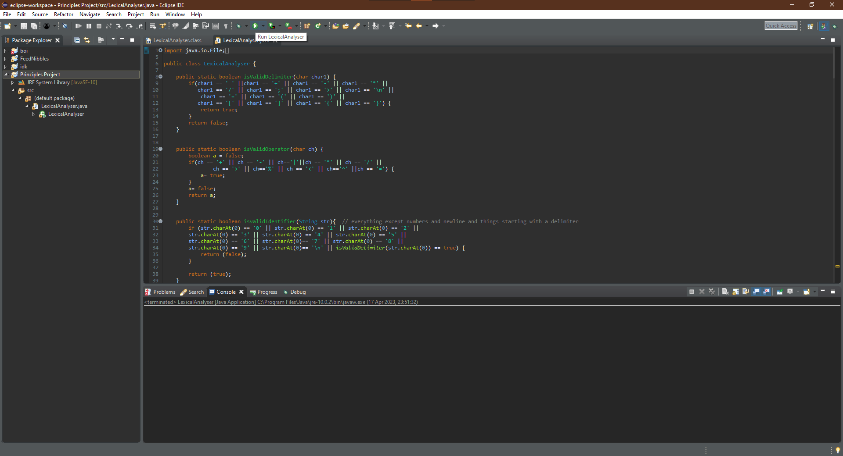

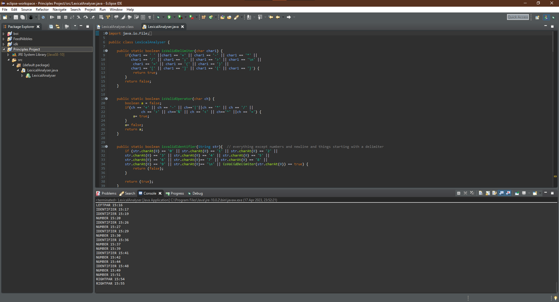

**Complete/Incomplete Parts of the Assignment**

Comments, brackets, boolean literals, keywords and identifiers can be successfully analysed within the input and the tokens’ category is printed back to the user. The program is able to detect and inform about some incorrect inputs but instead of terminating itself, it continues to analyse tokens and may detect some tokens incorrectly. String and char literals are not detected, their respective methods are empty. Number literals are correctly analysed except the ones with plus or minus signs in the beginning. The program does not take the name of the input file from the user, it takes a text file with the name “input.txt”.

**Outputs for the Given Inputs**

**Input 1:**

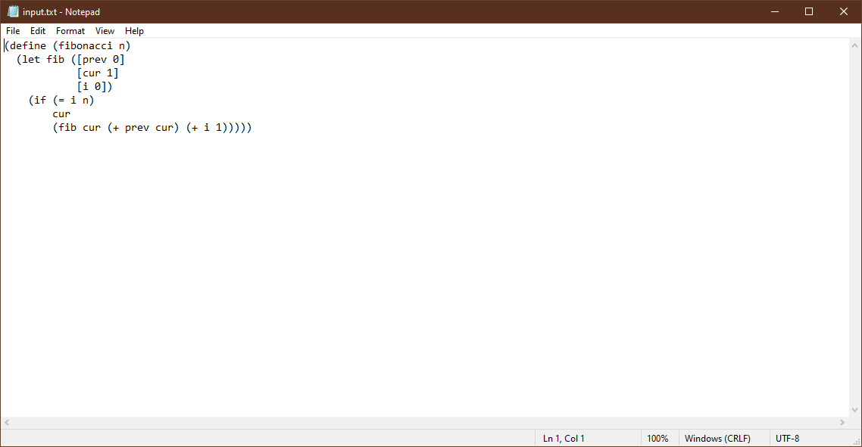

**Output 1:**

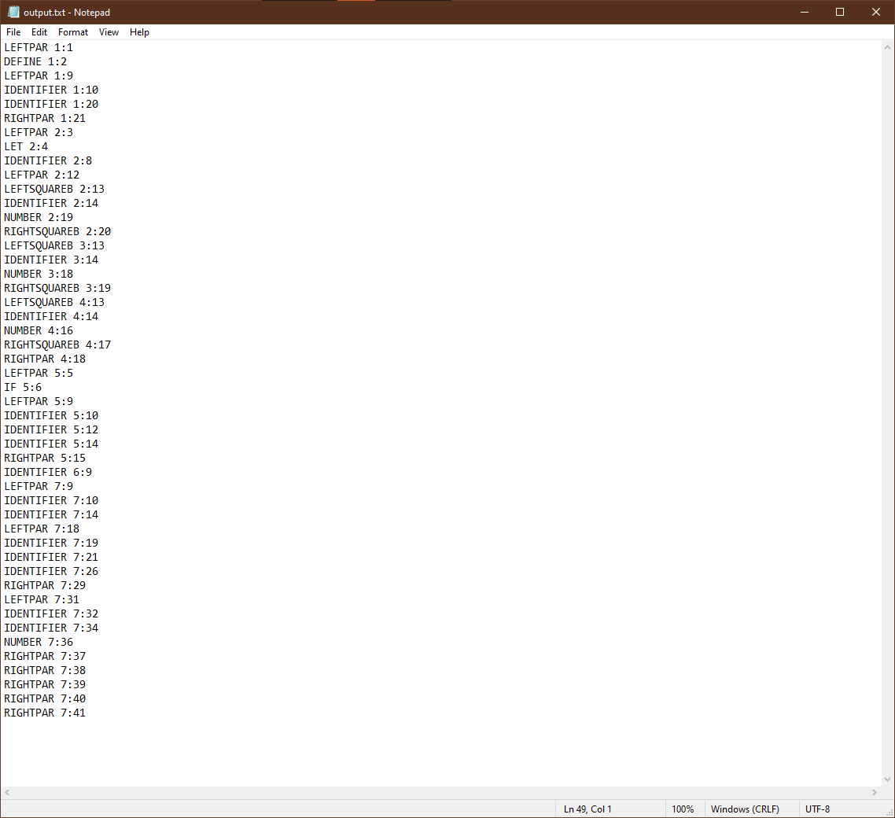

**Input 2:**

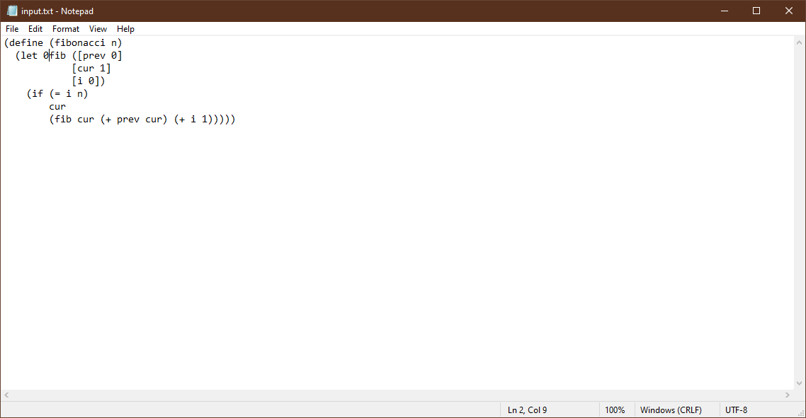

**Output 2:**

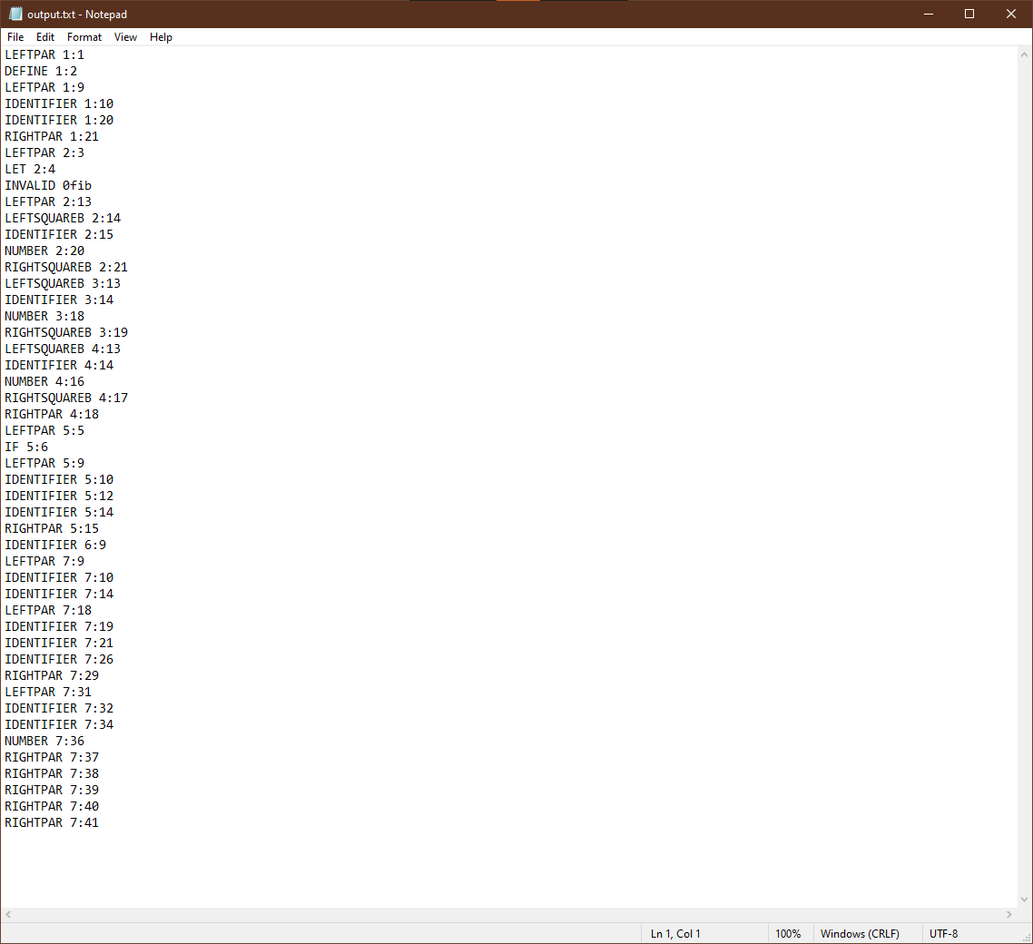

**Input 3:**

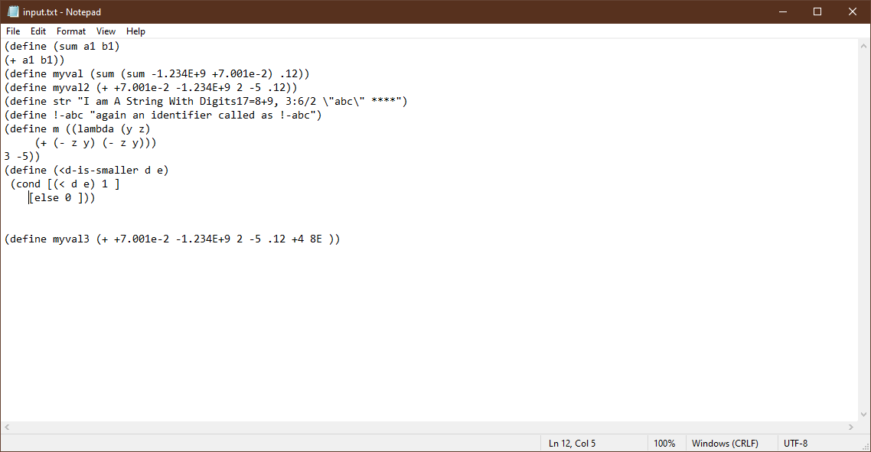

**Output 3:**

